How TO Install Techplot 360 in Microsoft Window 10

1. Run techplot360setup.exc file. It is available on CC ftp Site.(Extracting:Tecplot3610.msi).

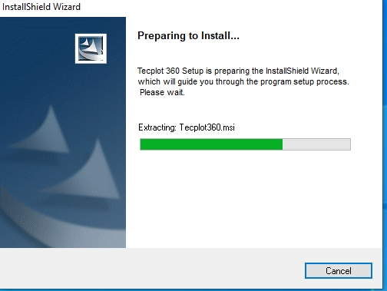

1. Click on “Next” button.

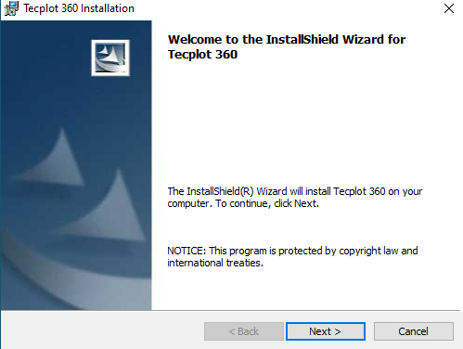

1. Select “I accept the terms in license agreement” and click “Next” Button option.

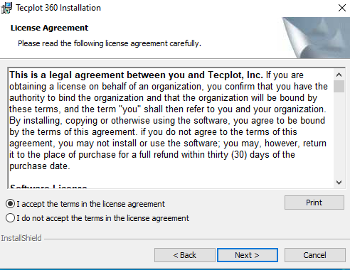

1. “Select Licence type” then select “Network Licence” option.

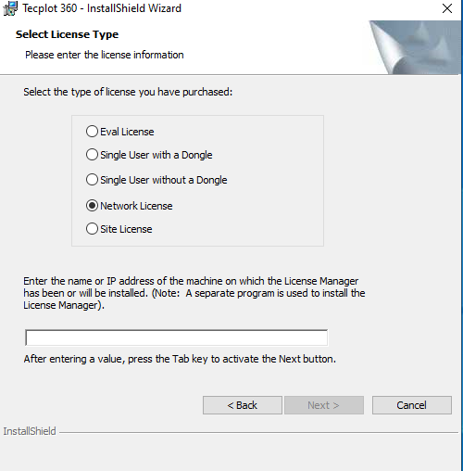

1. Enter the “Network Licence Server” IP Address in the Server name box (Network Licence Server IP are: “0172.31.1.4 or 172.31.1.5” and Click activate.

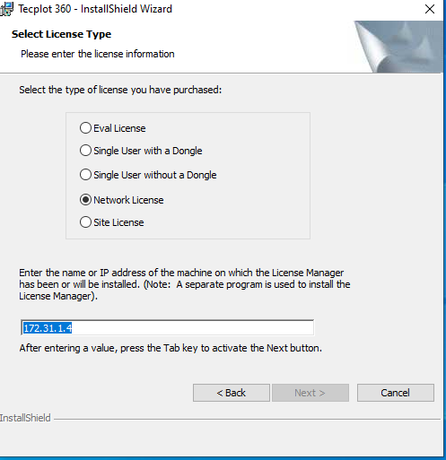

1. After Entering the IP Add of Server, Press the “TAB” key to activate the “Next Button” and Click “Next” option.

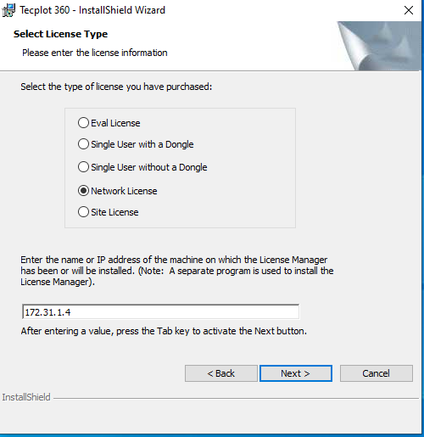

1. Click on “Next” Button.

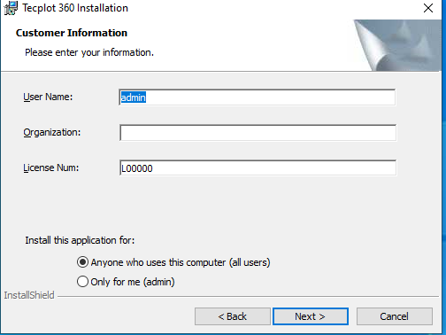

1. Click on “Next button” option.

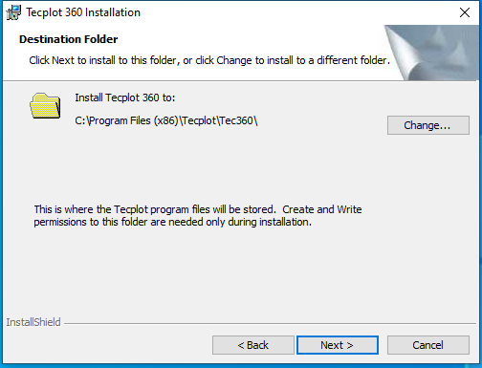

1. Click on “Next Button” option.

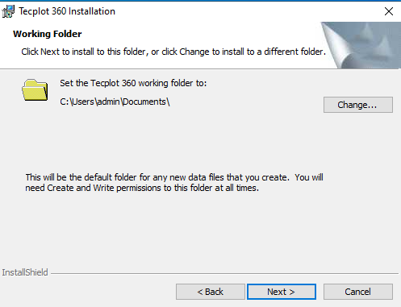

1. Click on “Next Button” option.

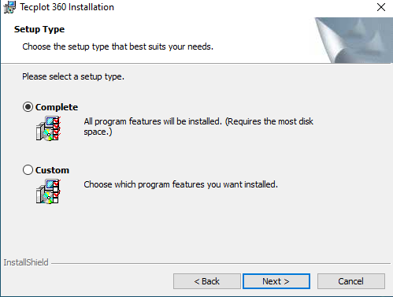

1. Click on “install Button”.

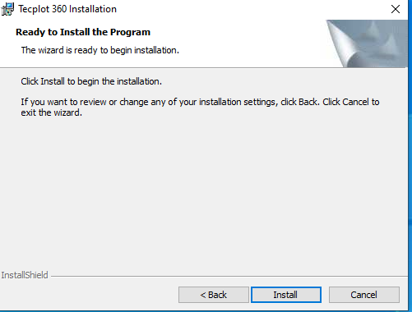

1. Wait a few Minute for the Installation to complete.

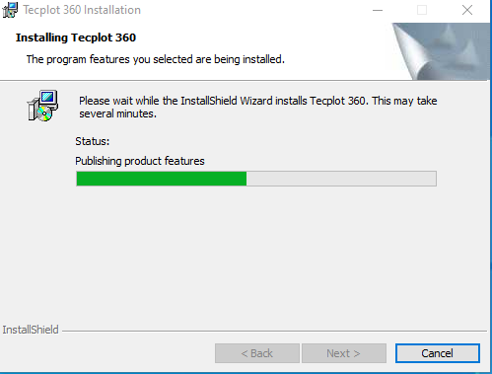

1. The Installation process Completed then Click on “Finish button” option.



1. Preview of Techplot360 as Below:

